Fête au Village, Legal AB
Celebrating Family, Friends, Community & Home!
Saturday, July 22nd, 2022
Parade Registration

Please fill in Registration form and return copy to ATTN: PARADE
Business or Organizations Name:
Our Business or Organization will be: | Walking Biking / Riding Driving
Size of Float or #of Walkers/Bikers:
My float will have: | Animals (ie: Horses) Music Playing Large group of children
Main Contact Name:
Main Contact Phone:
Main Contact Email:
Comments or Questions

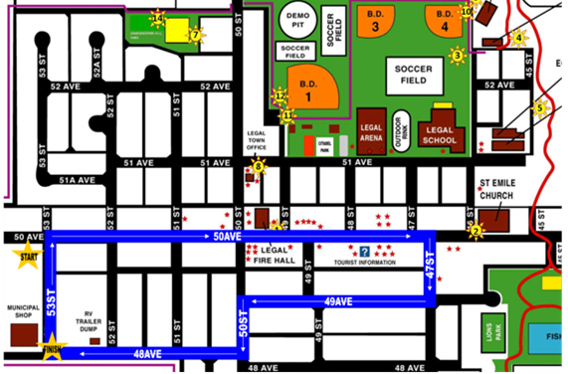
Main Saturday Parade:
Staging: 9:30 am
Location: Town of Legal
Municipal Shop 5310-48Ave
Parade Starts: 10:30am

We welcome to participants to throw candy at our parade.
Water balloons or water guns not allowed.

FREE REGISTRATION – Please pre-register your business or organization with:
Attn: Amber Email: feteauvillage@gmail.com

Pre-Register by July 15th and be entered in a chance to win $75.00!

Full event details found at:
www.feteauvillage.com

Date Received: Received by:
PARADE
In consideration of participating in the Saturday Main Parade at the FETE AU VILLAGE I DO HEREBY for myself, WAIVE, RELEASE and FOREVER DISCHARGE any and all rights and claims for damages, including any claims of loss, damages or injury to my person or property arising from participating in the Saturday Main Parade at the Fete au Village, held in the Town of Legal the owners of any event sites, any volunteers, their agents, representatives, successors and assigns.
I HAVE READ THIS WAIVER and knowing these facts, I hereby for myself, my heirs, executors, administrators or anyone else who might claim on my behalf, covenant not to sue and waive, release and discharge volunteers, suppliers, agents, employees, and other personnel in any way assisting or connected with the events from any and all claims or liability of any kind or nature whatsoever arising out of my participation, even though that liability may arise out of negligence or carelessness on the part of the Fete au Village, held in the Town of Legal, AB.
I accept the above stated conditions and do not hold the Fete au Village, held in the Town of Legal AB or its staff and/or affiliates, or volunteers, legally responsible for any loss, damage or theft incurred to myself, my employees or my goods and equipment during this event.

Date: ______________________________________ Printed Name: _________________________________

Signature: _____________________________________

