DEMOLITION DERBY
LEGAL FIRE DEPARTMENT RULES & REGULATIONS

RULES AND REGULATONS DEMOLITION:
- We are not a member of the demo association and do not run by their rules.
- Entry fee is $50.00 per car is non refundable and includes drivers gate pass.
- Demo vehicles not present 1 hour before race time will not be accepted.
- Heat numbers will be drawn before race.
- Drivers must obey flagman.
- All drivers must sign a waiver form. Under the age of 18 MUST have parental consent.
- All flags will be explained prior to race.
- Drivers must wear crash helmets and seat belt.
- All vehicles must have adequate brakes and steering.
- All glass, plastic ornaments, lights, gas tanks, trailer hitches, outside mirrors, chrome strips, etc. Must be removed
- Doors and trunk lids MUST BE CHAINED. All tail gates MUST BE CHAINED.
- Back seat must be removed. No exceptions.
- All vehicles must have hoods, hoods must be chained or bolted shut. If bolted only 2 bolts may extend through the frame. Hoods must remain in stock position. Hoods must be open able (bolting will not be permitted).
- All vehicles must have all exterior chrome removed and wheel weights removed.
- Original tank MUST BE REMOVED. The gas tank must be relocated to a position in the rear seat area of the car or inside the truck box, behind the cab.
- Radiator must remain in engine compartment.
- Driver’s door MUST be painted a different color.
- Horizontal bracing on either driver or passenger or both doors is optional providing it extends no more than 6-inches either side of the door. Rear door bracing will not be required.
- Vertical bracing will only be permitted behind the driver’s seat. No other vertical bracing will be permitted.
- Absolutely no reinforcement or hitch on cars or they can be disqualified at any time.
- Original cooling system must be used; radiator must remain in the stock position. Rad mounting may be changed to prevent twisting. Aux coolers are not allowed. Fans may be trimmed or removed.
- Frames must be stock, no reinforcement, stock height must be maintained. Any frame repairs must be reposted to officials.
- Bumpers and bumper shocks may be welded to the frame but no extra reinforcement is allowed.
- Battery must be relocated to passenger side floor area. It must be properly secured (i.e. bolted with a bracket to the floor) and covered with rubber (i.e. a piece of rubber tube).
- Wheel wells opening and bumper ends may be trimmed.
- The engine compartment firewall may be cut for distributor clearance but must be covered in such a way to prevent hot fluids from entering driver’s compartment.
- If you are removing the dash, a pipe can be welded across the car to support the steering column.
- Protective door bars will be allowed on both sides of the truck, they must be bolted and/or welded on. Ty must not exceed 10 inches in width and 7 feet 6 inches long. Channel iron or square tubing is recommended to be mounted in each vehicle.
- Truck will be STOCK 2WD or 4WD. Front drive shafts on 4WD truck MUST be removed. Gas tank to be located in box of truck near the center of cab.
- While racing any vehicles not moving a reasonable distance for more than 1 minute will be disqualified from the race (driver will be instructed to break his or her flag.).
- Alcohol and drug use will not be tolerated and users will not be allowed to race.
- Only 1 driver and 1 pit person per car are allowed to be in the pit area.
- Remember this is a family show so please be courteous & respectful to everyone.
- Vehicles must be removed from grounds immediately after the demo.
- Air horns and flags will be used to stop demo heat.
- NO profanity on cars, Fire Dept. has the right to refuse entry or spray paint over the profanity prior to the Demo.
- Station wagon, sedans and hard tops are acceptable. NO vans, convertibles, hearses or Chrysler Imperials allowed.

If a rule is not covered here, this does not mean it is legal. If you require further clarification, contact Legal Fire Department at LFDstation3@hotmail.com
Interpretation of rules is at the official’s discretion. Officials’ rulings will be final.

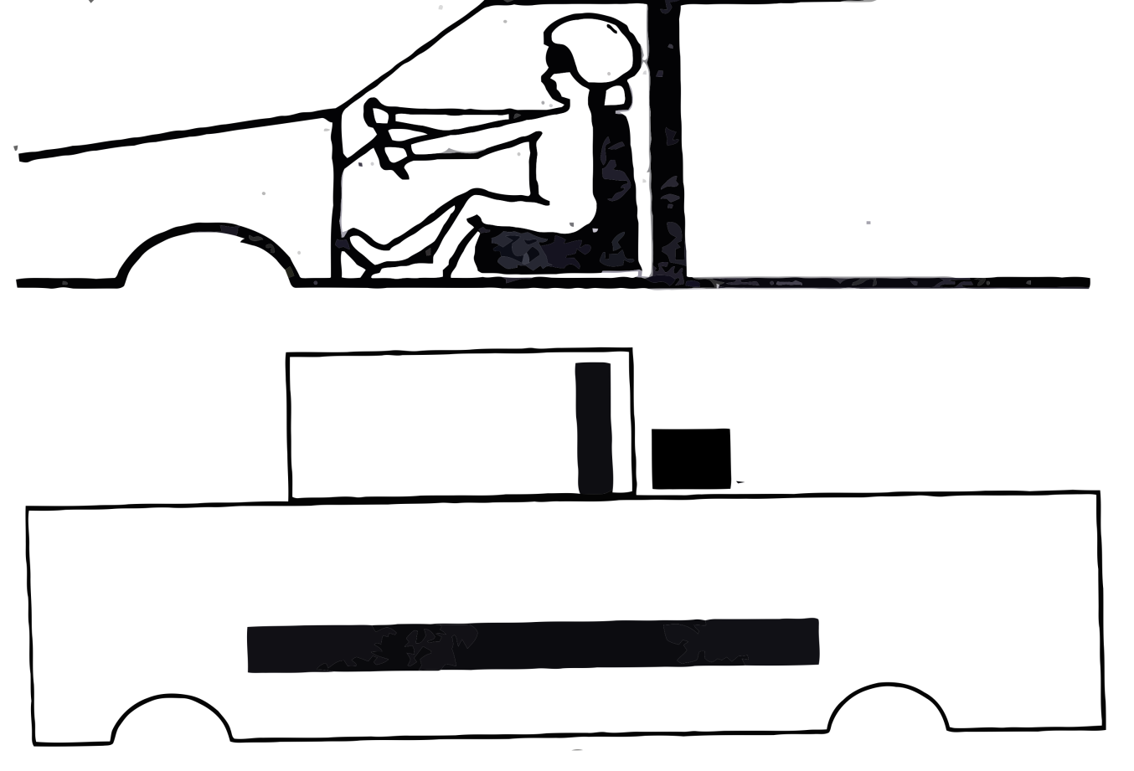
Headrest
Pad

Seat Brace

GAS TANK

I HEREBY WAIVE MY RIGHT TO ALL CLAIMS OR ACTION AGAINST THE TOWN OF LEGAL AND ANY AFFILIATED DEPARTMENTS AND/OR EMPLOYEES, REPRESENTATIVES OR PARTICIPANTS IN THE FETE AU VILLAGE DEMOLITION RACE FOR ANY INJURY OR EXPENSE INCURRED BY ME DURING THE RACE.

DRIVERS LICENSE NUMBER _______________________________________
DRIVERS NAME (PRINT) _______________________________________
DRIVERS SIGNATURE _______________________________________
ADDRESS _______________________________________
DATE _______________________________________
PARENT OR GUARDIAN NAME (PRINT) _______________________________________
If a rule is not covered here, this does not mean it is legal. If you require further clarification, contact Legal Fire Department at LFDstation3@hotmail.com
Interpretation of rules is at the official’s discretion. Officials’ rulings will be final.

Revised April 27, 2022

